Name: Mukesh Raj L(192571036)

JIRA EXPERIMENTS
EX01- KAMBAN BOARD
AIM:
To Create a Kanban Board to Visualize the Tasks.
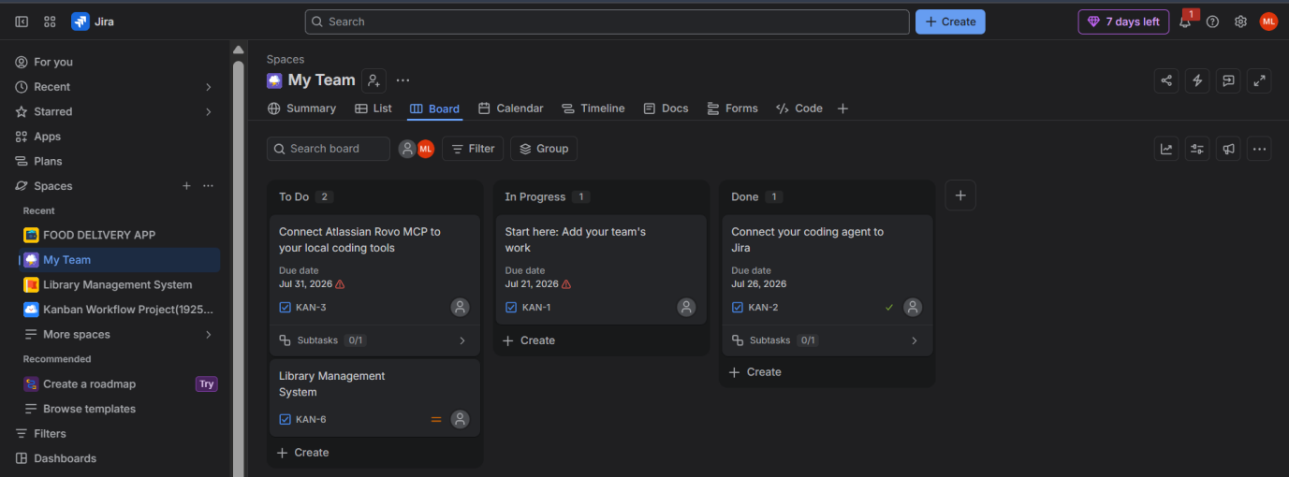
RESULT
The Kanban Board was successfully created with To Do, In-Progress, and Done columns. Five sample tasks were added, and tasks were moved across the columns to simulate the project workflow, enabling effective visualization and tracking of task progress.

EX09- LIBRARY MANAGEMENT USING MOSCOW
AIM
To create a Scrum project in Jira, add backlog items, prioritize them, create a sprint, start the sprint, and track progress using the sprint board.

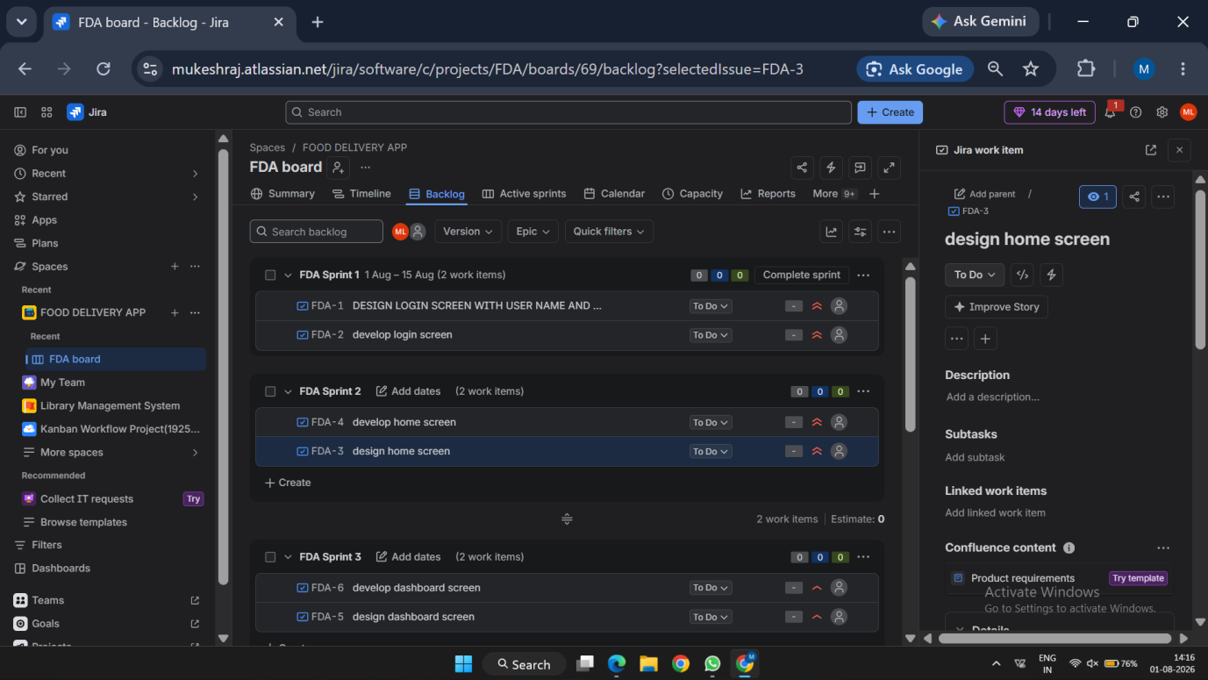
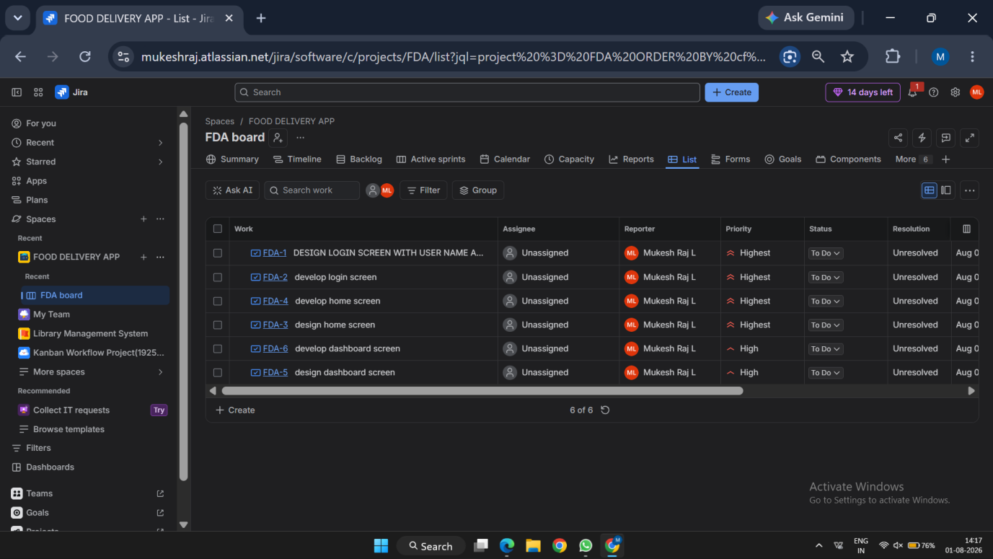

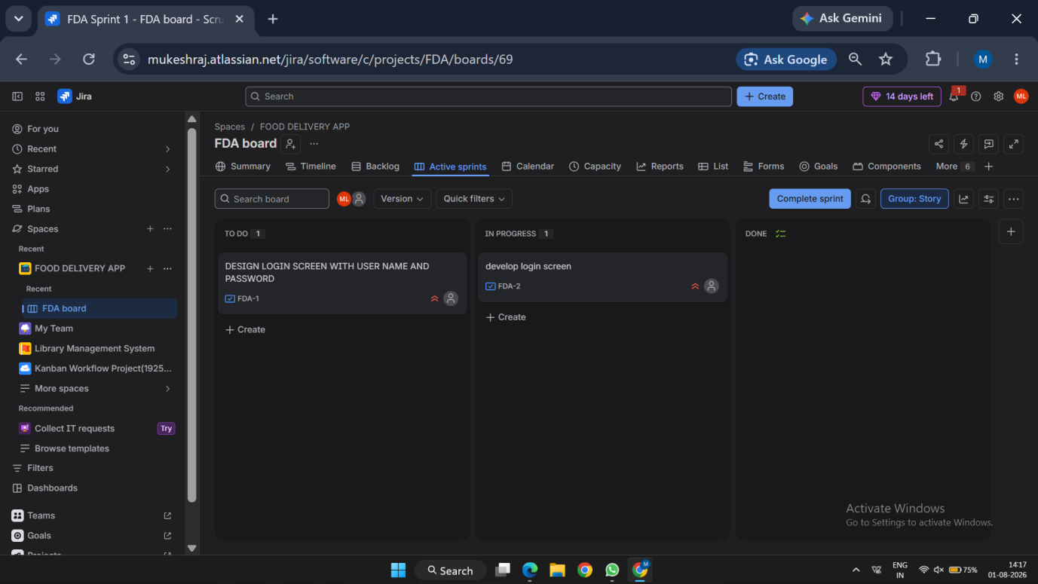

Result
Thus, a Scrum project was successfully created in Jira with backlog prioritization, sprint planning, sprint execution, and sprint completion.

EX11 - LIBRARY MANAGEMENT WITH CONFLUENCE
AIM:
To Link Jira tasks with Confluence to streamline task tracking and progress monitoring for the Library Management System development.

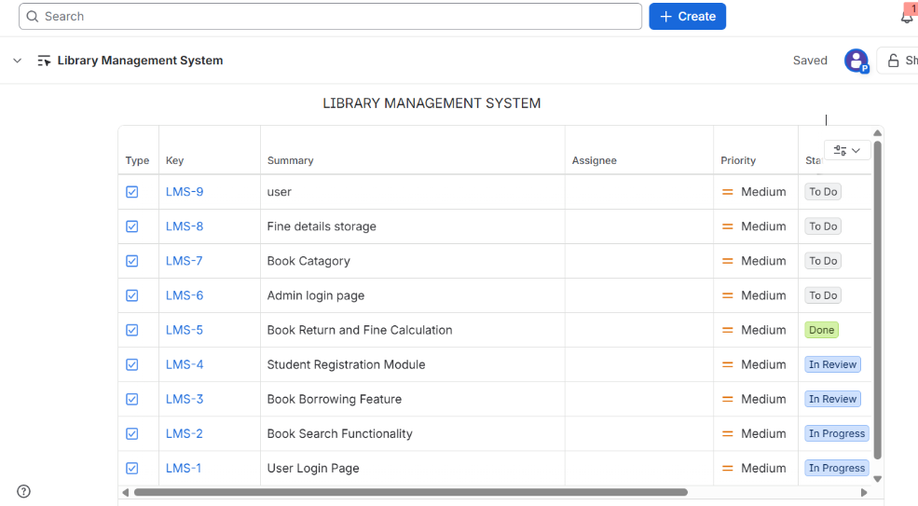
Result:
Thus, Jira tasks were successfully linked with Confluence to streamline task tracking, documentation, and progress monitoring for the Library Management System development.

EX12- Task Management System
AIM:
To designing a Task Management System for a small team.
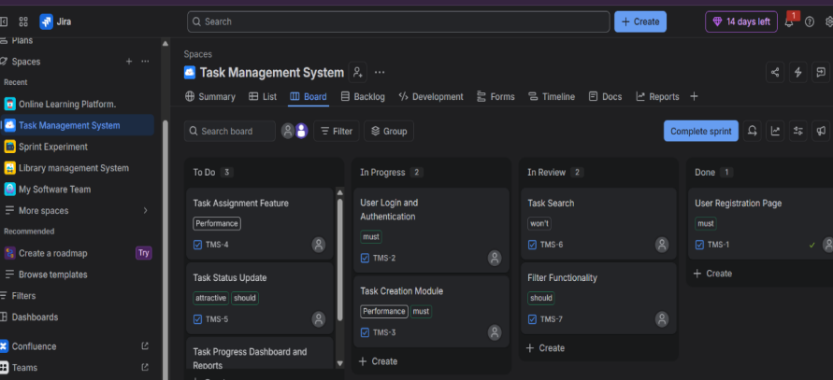

Result:
Thus, a Task Management System was successfully designed in Jira for a small team to create, organize, assign, and track tasks efficiently.

EX13- ONLINE LEARNING PLATFORM.
AIM:
To develope an Online Learning Platform.

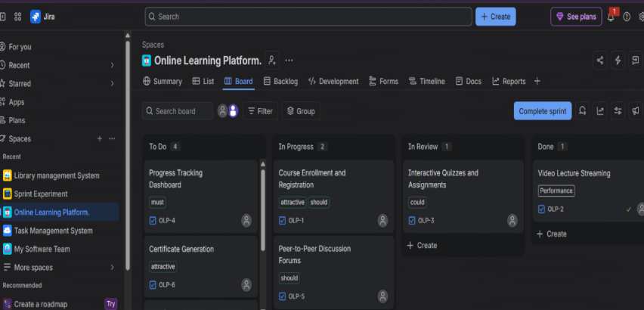

Result:
Thus, an Online Learning Platform was successfully developed and its tasks were organized and managed using Jira for effective project tracking and workflow management.

